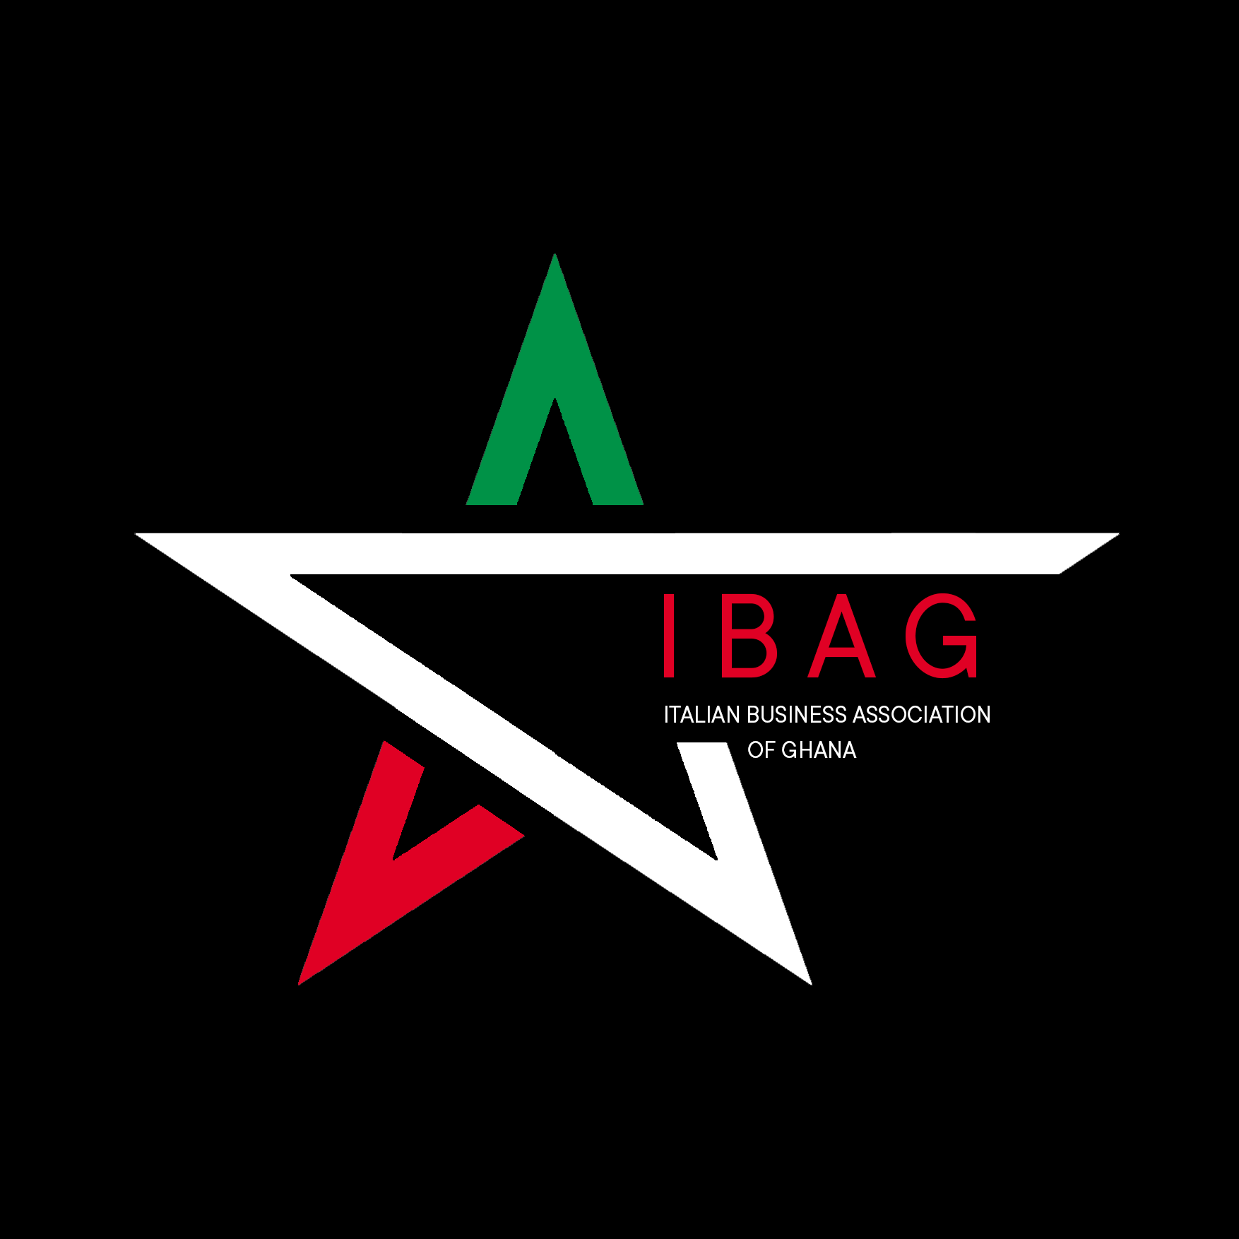

IBAG MEMBERSHIP FORM
DISCLAIMER!

To protect the integrity of the association, each application is vetted by the executive board. Should the board be in need of any clarifications, they will contact you within days of your document submission.

Once membership is granted, you will receive a congratulatory email, after which you will be required to pay the membership fee applicable to you, based on your Ghanaian business registration title;
I. 1,450 Ghanaian Cedi to register as a Non-Governmental Organization (NGO)
II. 2,750 Ghanaian Cedi to register as a Limited Liability company (LLC)
Individuals are welcomed to join. Individual status membership fees are set at the discretion of the EXECUTIVE BOARD.
Kindly note that we will require a scan of your business registration documents as well as your business logo.

Please fill your details below, where applicable to you;

NAME --------------------------------------- -------------------------------------
First name Surname

NATIONALITY -------------------------------------------------------------------------------------

TYPE OF REGISTRATION -------------------------------------------------------------------------------------
Limited Liability Company (LLC), Non-Governmental Organization (NGO), Individual

COMPANY NAME --------------------------------------------------------------------------------------

IN BUSINESS/ IN GHANA SINCE? (DATE) -------------------------------------------------------------------

TYPE OF BUSINESS (INDUSTRY) ------------------------------------------------------------------------------
CONTACT INFORMATION

Tel number -----------------------------------------------------

Email address -----------------------------------------------------

Postal Address -----------------------------------------------------

Street name -----------------------------------------------------

Region -----------------------------------------------------

Website ----------------------------------------------------

SOCIAL MEDIA HANDLE -------------------------------------------------------------------------------------
HOW DID YOU HEAR ABOUT US?
Word of mouth ☐
News article ☐
Social media ☐
Google search ☐
Others (Please specify) …………………………………………………………………...

Would you like to be added to the monthly newsletter mailing list?

YES ☐
NO ☐

Would you like to be added to the members WhatsApp group?

YES ☐
NO ☐

Granted membership,

I (full name) ----------------------------------------------------------------------------------, hereby declare to uphold the overall objective of IBAG which is ‘ to contribute to the economic and cultural partnership between Italy and Ghana’‘. I am committed to the compliance of the statutory regulations and provisions set by the BOARD OF DIRECTORS. I further undertake not to use the name of the Association for any commercial activity without the express written consent from the BOARD OF DIRECTORS. I pledge to pay the renewable annual fee of ---------------------which entitles me to participate in all IBAG’s activities.

DATE & SIGNATURE --------------------------------------------------------------------

